Good day, Star date 01192020
Hello Brother and Sister Moose secretaries. This is ONE way of doing labels and reports for LCL Web Export. This is NOT a save all instruction sheet, just some knowledge that I can pass along. I am not a Microsoft Expert, so there could very well be better ways of doing this and I will try to update as I learn and the options grow. (I am in hopes that M.I. figures out how to get reports back online.) If you find or know a shortcut, PLEASE share it with me, or even a question and I will see what I can find. (Short of reading a book!)
These instructions and images are based on Microsoft Office 2016 WORD and EXCEL. IF you have a different version of Microsoft Office, it should still work but look a little different. If you are using Open Office, I wish you luck. I tried to figure out how to do it, and gave up.
So, with all that said, grab an adult beverage (Or if your at the Lodge home, grab a coffee or an Ice Tea if you know what I mean) and lets get started. Thank you for all you do for Mooseheart and Moosehaven and remember its only a couple of hours a week. (Wink, Wink)

Respectfully,

Sean Smith
Michigan Moose Communications Chairman and Admin #763
sean.mimoose@gmail.com

Instructions to print labels from LCL Web on Microsoft Word & Excel. (Must have the programs)
- Open LCL web and log in.
- Top header hover over “Reports” select “Export” from drop down.
- In the options box under “Member Fields” select the boxes for
  - Dues Expiration Date
  - First Name
  - Middle Name
  - Last Name
  - Suffix
  - Address Line 1
  - Address Line 2
  - City
  - State/Province
  - Zip Code
  - Optional (Home Phone, Work Phone, Cell phone)
- Once all the options are marked in blue, select the “Add >” button to move them to “Report Fields” box.
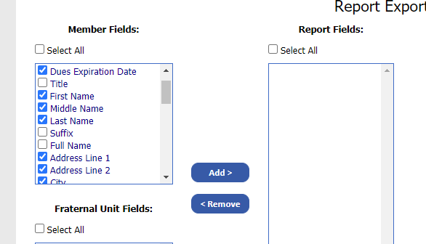

- It will then move all your options to the “Report Fields”
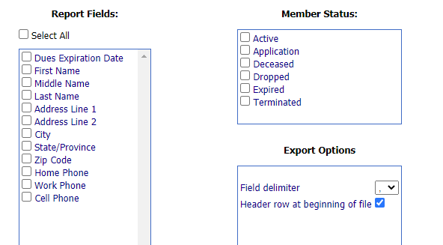
- In the “Member Status” Box, select what membership pool you wish to print from.
  - Active are only members with current dues dates on their cards.
  - Application is only members in the Application status.
  - Deceased is only members that have been marked deceased on the record.
  - Dropped is only members that are expired and up to 1 year past.
  - Terminated is only members that are 1 year past expired status.
- So for a dues reminder listing we will select the “Dropped” status.
- Bottom right of form select the button labeled “Export Data”
- It should have downloaded a form to your “Downloads” folder on your computer. You MAY see an icon pop up that says “FRUAdminLCL_Report_Export.csv downloaded”
THIS PRINTS ALL DELINQUENT MEMBERS. IF YOU WANT TO SORT BY MONTH SEE APENDEX A

Congratulations, step ONE complete. Now get a drink, because its going to get fun!
To save a lot of trouble, download my template on the website CLICK HERE
- Open your Microsoft Office “Word” software. (Each version is a little different, but the clicks should be about the same.)
- Double click “Blank Document” if you did not download the template from MMA website.

- On the top row of options, Select “Mailings”
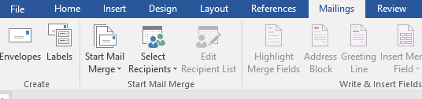

- Select “Start Mail Merge” and in the drop down select “labels”.
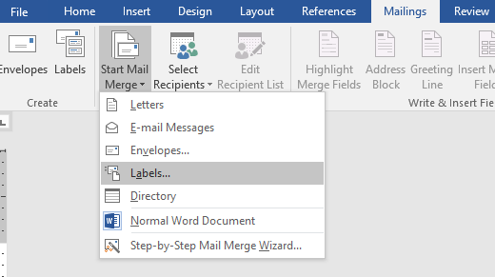
- Select “Avery US Letter” in “Label information” and 5160 for product number if you are using the 30 mailing label sheets. Select “Ok” and it should take you back to a page that looks like your label sheet.
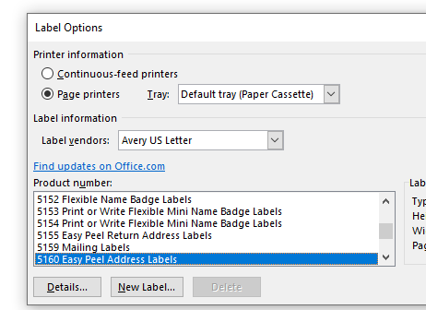
- Select “Select Recipients” from the header bar and select “Use an Existing list”
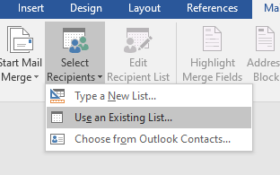
- This should open a window “Select Data Source”. In the left side panel you want to find the “Downloads” folder. In the Downloads folder, find the “FRUAdminLCL…” and select it and then select “OK” at the bottom of the window.
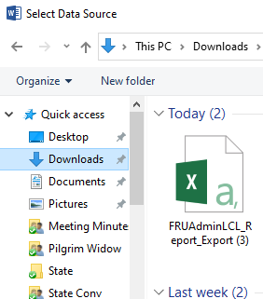
- In the header bar select “Match Fields” and make sure each of your address lines have a corresponding name. (Mine does not match State and Zip)
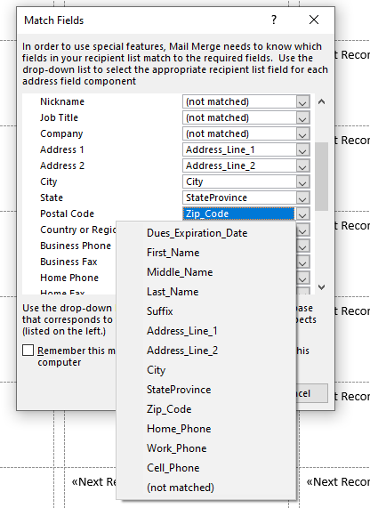
IF YOU DOWNLOADED THE TEMPLATE, skip to step 23 (I hope)

- In the header bar next to the Match Fields, select “Insert Merge Field”
- In the menu, highlight First_Name and click Insert, Middle_Name click Insert and do the same for Last, Suffix, Address 1, Address 2, City, State, Zip
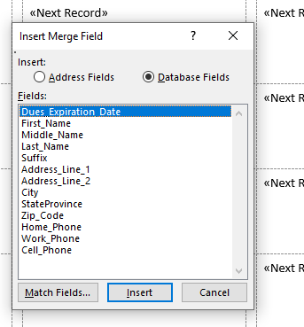
- Once you have all your option in, select cancel to close the Insert Merge Field.
- You will need to put returns and spaces in the label so they line up correctly
- Once you have your first label designed, click the “Update Labels” under the Match Fields option in the header bar. This should add your First Middle Last to the rest of the labels so they look like this. (I leave both addresses on one line.)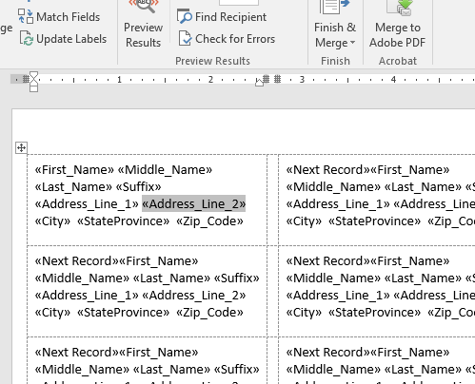

- Now you should be able to select “Finish & Merge” button in the Header bar. Then select “Edit Individual Documents” and then select ok.
- You should now have a new document with all your labels and the members names.

(IF you need to tweak how the label looks because something doesn’t line up. Close this window Labels – Word and it will take you back to the design one.) Change the first label around and then remember to click “Update Labels” and back to #23

- You should now be able to print the labels. I test mine on plain paper first, and then reprint on label paper when I see what I like.

Appendix A – How to sort dues dates
- Select “Edit Recipient List” in the header bar and then select “Filter” and this will open the Query Options.
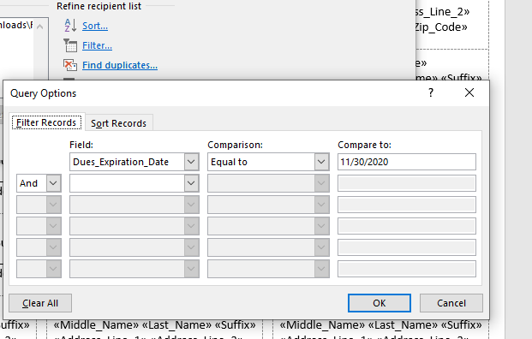

- In the Field Box select the dropdown arrow and select “Dues_Expiration_Date”, in the Comparison box “Equal to”, and in the compare box the month you wish to print. Here are some examples of how it should look entered.
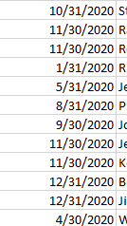
- Select Ok at the bottom and you can now return to step #23 and print labels.
Appendix B Calling List Report in Microsoft Excel
- In Microsoft Excel you can open the file “FRUAdminLCL_Report_Export”
- The columns may look a little crunched so you cant see the info.
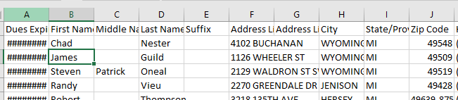
- Double click (Click Twice) the line between the two columns, (so that line between A and B, or B and C, or so on). This will automatically expand the column to whatever size it needs to show all information in that column. (Be careful with the Address column, some addresses are LONG)
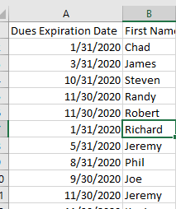
- If the column is wider than you want, you can click and hold the line between the two columns and drag it back to where you want it. (This will hide some information in that column somewhere. But if you are here for the phone numbers, the address column info wont matter unless you want verify the address when you make your calls.)
- If you want to bring the phone numbers next to the name, you can cut and paste the columns where you want them. Select the letter of the column you want to move. Then right click your mouse to get the options menu.
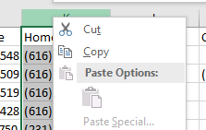

- Select the “Cut” option.
- Now go to the column where you want it to be and select the letter of that column. Right click again to open the options menu and select “Insert Cut Cells”
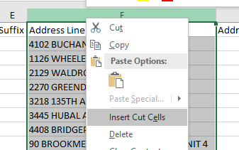
- This should have moved the Address Column over and put the Phone Number column in the middle. So now you could print the report and have the numbers right next to the names.

